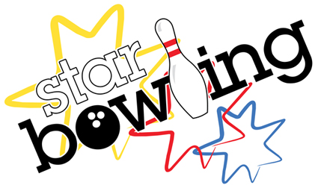
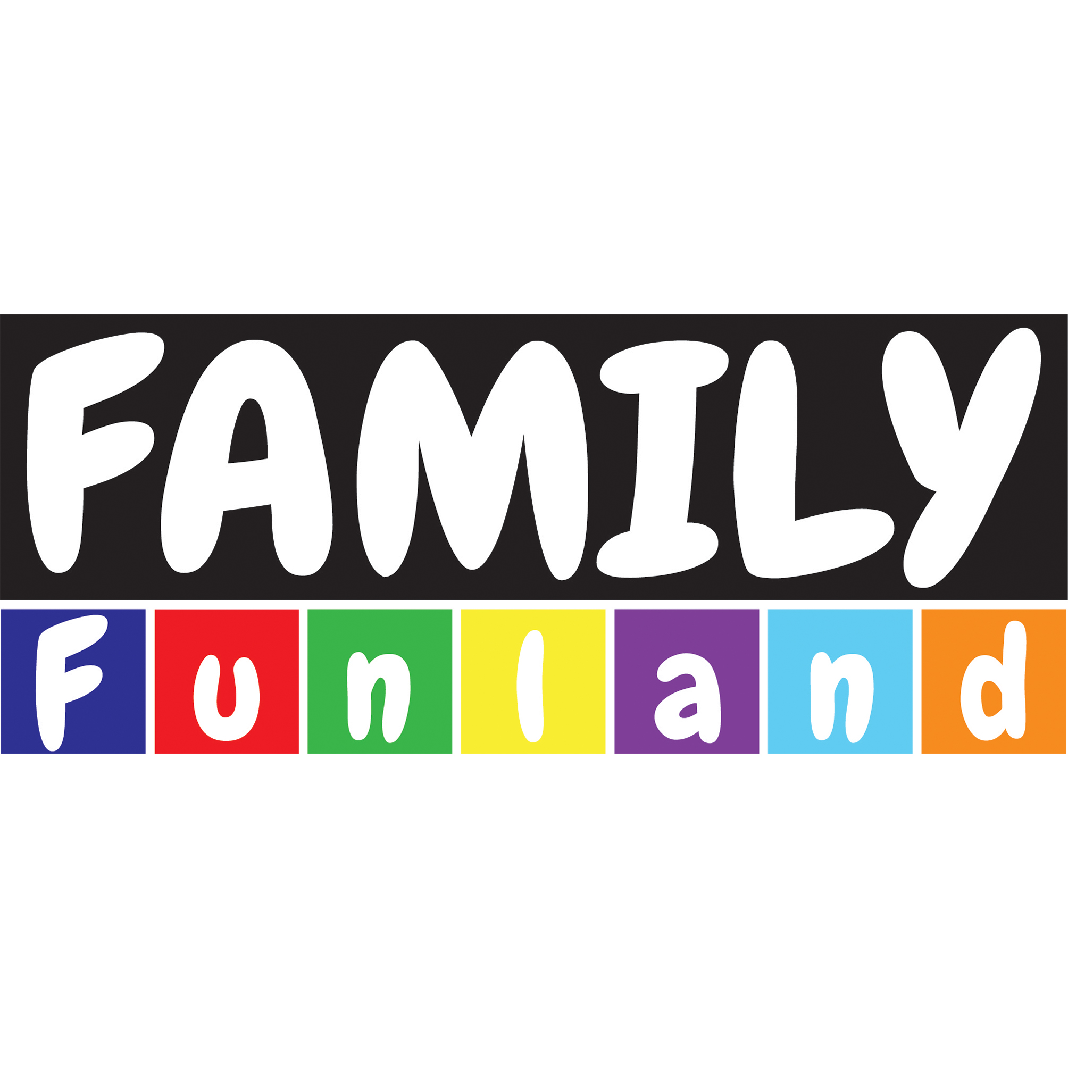
BIRTHDAY PARTY BOOKING
INITIAL NON REFUNDABLE DEPOSIT PAID $50 YES NO _____________________
(include stapled receipt to the front of this booking)
EXTRA DEPOSIT PAID AND AMOUNT
(extra repayments are refundable)
Did the customer book in February (10% discount, please write date booked) _______________________________
CONTACT DETAILS
*Parent or Guardian (full name): ____________________________________________________
*Mobile/Home: ______________________________________________________________
*Confirmation Contact Email_____________________________________________________________
BIRTHDAY CHILD/CHILDREN DETAILS
*Date of Party: ___________________* Time of Party (10.30am onwards) ________________________
*Birthday Child: __________________________ *Age on party date: _________________________
*Boy or Girl: ______________________________ *Theme/ Color: ______________________________
* Most umber of kids attending all doing the full package chosen _______________________________
* Number of PARENTS ATTENDING on the day_____________________________________________
* Number of rooms needed for the party_______________________________________
____________________________________________________________________________________ HOSTING
Time needed for host : ________________ AM/PM to _________________ AM/PM
Who is Hosting? _________________________________________________________________
(Please fill in when roster is out to make sure that there is someone available to host – if not please message your manager about this)

ADDITIONAL BOOKING DETAILS
*Is the customer bringing their own decorations that we need to set up (we prefer to do the night before rather than the day for organization)
________________________________________________________________________________________
*When will the decorations be dropped off and setup by a supplier or by the parent booking?
_________________________________________________________________________________________
* Party Duration: (remember if adding attractions the time in the room is increased depending on the duration of the attraction)
______________________________________________________________________
* If Parties have more than 30 kids have you explained to the customer the time limit on the party will be increased by 30 mins
_____________________________________________________________________________________
Package:
THE FOLLOWING ONLY
- LETS BOWL PARTY $25pp _____________
Or
- BOWLCADE PARTY $36pp ______________
Or
- ALL STAR BOWL PARTY $45pp _____________

PACKAGE DETAILS
* Will the party be split into different packages and is the customer fully aware of what each group will be doing __________________________________________________________________________
* Will the children be adding any extra attractions to the package? Eg mini golf ($5), laser($5) dark ride($5) bouldering($5), bowling($5), or cinema($11)
___________________________________________________________________________
* Will the parents be doing any discounted attractions with the party? ____________________________
_______________________________________________________________________________________
Food Option: (HIGHLIGHT); only 1 option per party; any other additional food is to be put through as a platter. Food and drink options are only to cater for UNDER 16’S. All over 16 need to purchase food and drink separately.
FOOD OPTION 1 – NUGGETS, CHICKEN CHIPS, COCKTAIL FRANKS AND CHIPS (3 X NUGGETS, 3 X C/CHIPS, 2 X FRANKS, 1 X PLATTER CHIPS PER 10 KIDS AS A GUIDE FOR FOOD PORTION)
FOOD OPTION 2 – HOTDOGS AND CHIPS (1 X HOT DOG, 1 X PLATTER OF CHIPS PER 10 KIDS
FOOD OPTION 3 – CHEESE BURGERS AND CHIPS ( 1 X C/B PER PERSON AND 1 X PLATTER CHIPS PER 10 KIDS)
FOOD OPTION 4 - PIZZA PLATTERS AND CHIPS (1 X MAXI PER 3 KIDS AND 1 X PLATTER OF CHIPS PER 10 KIDS)
FOOD OPTION 5 – PARTY PIES, SAUSAGE ROLLS AND CHIPS (2 X PARTY PIE, 2 X SAUSAGE ROLL AND 1 PLATTER OF CHIPS PER 10 KIDS)
FOOD OPTION 6 – MIXED FRUIT PLATTER AND FAIRY BREAD (1 X PLATTER PER 10 KIDS FRUIT, 1 X PLATTER FAIRY BREAD PER 10 KIDS)
* WHAT TIME WOULD YOU LIKE YOUR FOOD TO BE SERVED?
- ON ARRIVAL
- AFTER THE ATTRACTIONS (ATTRACTIONS MUST ALWAYS GO FIRST)
- AFTER THE ATTRACTIONS AND ARCADE
*Guests with food allergies or special requirements: YES NO
If YES list details ________________________________________________________
GLUTEN FREE =
LACTOSE FREE =
EGG ALLERGY =
NUT ALLERGY

PIZZA TYPES FOR KIDS FOOD OPTION (HIGHLIGHT)
*MIXER MARGHERITA *TOPPA SWEEPER *PORTSIDER MEAT
*HAWAIIAN HARKRIDER *CHICKEN CRANKER
*JERSEY SIDE PEPPERONI *VEGETARIAN CONVERT *CHILI BURNER
*KINGPIN SUPREMO *BAGGER CAPRICIOSA
JUGS OF DRINKS: (HIGHLIGHT) unlimited with food and drink option
*COKE *LEMONADE *CREAMING SODA
*LIFT *FANTA *COKE ZERO *WATER
*MIX OF ANY *MIX OF CORDIAL *MIX OF JUICE
EXTRA PLATTERS FOR ADULTS/KIDS (CATERS FOR AROUND 8 PEOPLE PER PLATTER)
HOT FOOD PLATTER - $80
(wings,arancini balls, garlic chicken balls,mini spring & samosas) FRUIT PLATTER - $80
(assorted fruits)
FRUIT AND CHEESE PLATTER - $80
(assorted fruits and cheese) ANTIPASTO - $90
(olives, peppers, sundried, assorted meats, cheese and sourdough) MIXED SANDWICHES - $ 70
(assorted sandwiches) SWEETS PLATTER - $60 (scones, biscuits cream and jam)
PIZZA PLATTERS - $50
(2 x maxi pizza types) FAIRY BREAD PLATTER - $45
GARLIC BREAD = $50 KIDS PLATTER - $65
(chicken chips, nuggets and chips) CEASAR WRAP PLATTER = $75
THREE FRIES = $30
TIME FOR PLATTERS TO BE SERVED (USUALLY AT SAME TIME AS PARTY FOOD)
______________________________________________________________________________________
PIZZA TYPES FOR PIZZA PLATTER OPTION (HIGHLIGHT)
*MIXER MARGHERITA *TOPPA SWEEPER *PORTSIDER MEAT
* PORTSIDER CHICKEN *HAWAIIAN HARKRIDER *CHICKEN CRANKER
*JERSEY SIDE PEPPERONI *VEGETARIAN CONVERT *CHILI BURNER
*KINGPIN SUPREMO *BAGGER CAPRICIOSA

COFFEE TAB FOR PARENTS
YES NO
REQUIREMENTS________________________________________

PARTY EXTRA ATTRACTIONS
1 GAME OF BOWLING PER PERSON $5 (OR 2 FOR $8) KIDS __________________ ADULTS ________________
1 GAME OF LASER TAG $5PP KIDS ___________________
ADULTS ________________
1 GAME OF DARK RIDE $5PP KIDS ___________________
ADULTS _________________
1 X ENTRY INTO BOULDERING (ALL DAY PASS) $5PP KIDS____________________
ADULTS _________________
1 X SOFT PLAY (ALL DAY PASS) $5PP KIDS_____________________
ADULTS __________________
1 X MOVIE TICKET $10PP KIDS ____________________
ADULTS__________________
PARTY EXTRA ATTRACTIONS
*ICE CREAM CAKE $40pp (RAINBOW)
*MASCOT COSTUME $80: __________________________________________
*PINATA - $60 *ICE CREAM CONE $2PP
*GLUTEN FREE EXTRA $5pp *LACTOSE FREE $5PP *EXTRA HELIUM BALLOONS $1 each
*LOLLY & POPCORN PLATTER - $40 (CATERS 8-10 KIDS) * EXTRA LOLLYBAG - $2.50PP
*OTHER NOTES ___________________________________________________________________________
LIST OF NAMES OF GUESTS ATTENDING
(Ask the parent to provide a list of names for kids attending the party so that the lanes can be ready for when they arrive)
___________________________ ____________________________ ____________________________
___________________________ ____________________________ ____________________________
___________________________ ____________________________ ____________________________
___________________________ ____________________________ ____________________________
___________________________ ____________________________ ____________________________
___________________________ ____________________________ ____________________________
___________________________ ____________________________ ____________________________
___________________________ ____________________________ ____________________________
___________________________ ____________________________ ____________________________
PAYMENT OPTIONS/OFFICEWORK NOTES:
INITIAL DEPOSIT PAID $50 YES NO ____________________________________
EXTRA DEPOSIT PAID AND AMOUNT
ENTERED INTO DIARY YES NO
EMAILED INFORMATION AND DATE EMAILED : YES,NO
EMAILED CONFIRMATION YES NO
(If it can be confirmed straight away then do it)
CALLED ON MONDAY/TUESDAY BEFORE PARTY TO CONFIRM
_______________________________________________________________________________________________
Booking Taken By: ____________________________________________________
Date Taken __________________________________________________________
Is it written in the diary? _____________________________________________________
Have you put the booking into the calendar and invited the relevant businesses?_________________________ __
Where have the decorations brought by the customer been stored?_________________________________________________________________________________________
(best to store in party cupboard at back in a labelled bag)
REMEMBER TO CONFIRM WITH PARENTS BEFORE LEAVING
1. ARCADE GAME GREEN SWIPERS UNLIMITED PLAY NOT UNLIMITED TICKETS
2. IS THE MOST NUMBER OF KIDS WRITTEN DOWN/ MINIMUM 8 KIDS EXPLAINED?
3. ALL PACKAGE CARDS HANDED BACK AT END DUE TO EXPIRY AT END OF DAY IF CHOSEN ARCADE
4. $50 DEPOSIT IS NON REFUNDABLE
5. INVITES RECEIVED AND WAIVERS EXPLAINED
6. PACKAGE FOOD AND DRINK IS FOR UNDER 16’S
7. IF PARTY IS LATE AND THERE ARE PARTIES BOOKED AFTER AND TIME EXCEEDED THEY WILL BE MOVED TO CAFE

